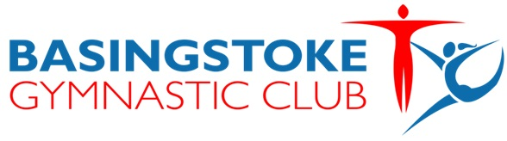

Club Welfare Officer
Working in a team of Welfare Officers and with management, coaches and other staff members and volunteers towards the common goal of achieving and maintaining a positive, child-centered environment. This is a challenging but positive role, enhancing the development of gymnasts through proactively reinforcing the importance of safeguarding and welfare.
Duties and responsibilities:
- Assist the Club to fulfill its responsibilities to safeguard children and vulnerable adults within the Club.
- Assist the Club in the implementation of its safeguarding plan for all children and vulnerable adults in the Club.
- Advise Club management on safeguarding issues.
- Act as the first point of contact for staff, volunteers, parents, children and young people where concerns about the welfare of children and young people and vulnerable adult’s welfare, poor practice or abuse are identified.
- Assist the Club to put in place policies for safeguarding and promoting the welfare of children and young people.
- Assist the Club with ensuring that Codes of Conduct are in place for staff and volunteers, children and young people.
- Promote the Club’s Code of Conduct within the Club.
- Implement and maintain the club’s reporting and recording procedures in line with British Gymnastics’ guidelines.
- Respond to child protection and poor practice concerns.
- Ensure confidentiality is maintained.
- Maintain contact details for the local children’s social care department, the police and local safeguarding children’s board.
- Promote anti-discriminatory practice.

Skills required:
- Child focused approach.
- Basic administration and record maintenance.
- Good communication skills.
- An awareness of the moral and legal responsibilities of all adults when working with children regarding their safety and well-being.
- The ideal candidate will be a parent or volunteer with professional experience in child protection and/or safeguarding eg: police officer, social worker, teacher, nursery worker etc.

Training required:
- British Gymnastics Safeguarding and Protecting Children Awareness Module or equivalent course recognised within another NGB (National Governing Body of Sport).
- NSPCC CPSU Time to Listen training for designated persons for child protection/welfare in sport (Club Level).
- A DBS check (Disclosure and Barring Service).
- Membership of British Gymnastics.

Following training the Welfare Officer must have the following minimum knowledge to perform in the role:
- Understand the boundaries of the Club Welfare Officer’s role.
- Take ownership of the responsibility to safeguard the welfare of children and young/vulnerable people.
- Basic knowledge of statutory agencies (Children’s social care, the police, the NSPCC and the Local Safeguarding Children Board).
- Local arrangements for safeguarding children and reporting procedures.
- Understand poor practice and abuse – all behaviour which is harmful to children.

